Task on Load Balancers
- Configure Classic Load balancer.
- In Load Balancer types page, scroll down to the bottom.
- Click Classic Load Balancer – previous generation.
- Click Create to start Classic Load Balancer configuration.
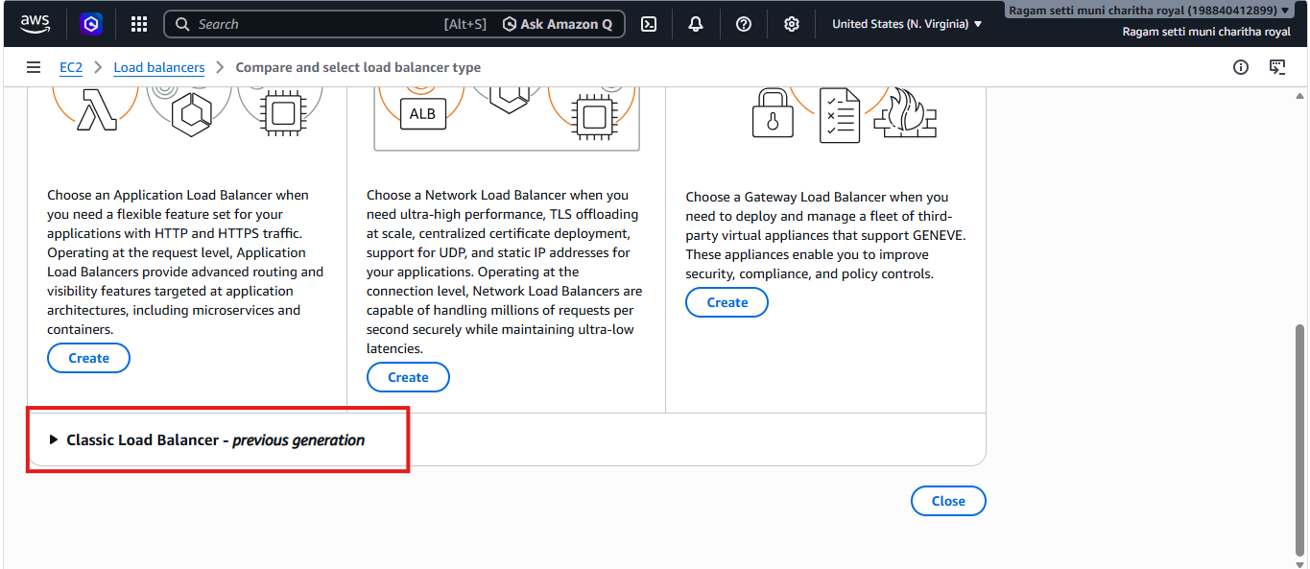
- Entered the load balancer name as classic-LB and selected Internet-facing scheme.
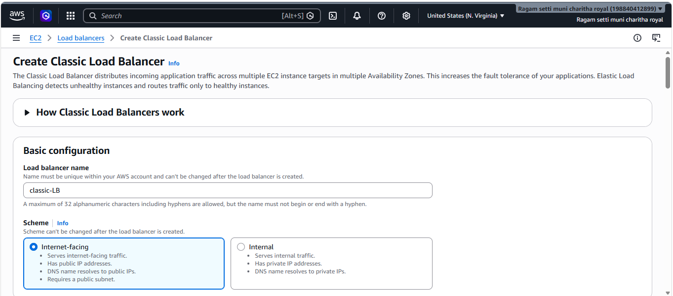
- Configured listener and instance protocol as HTTP with port 80 for traffic routing.
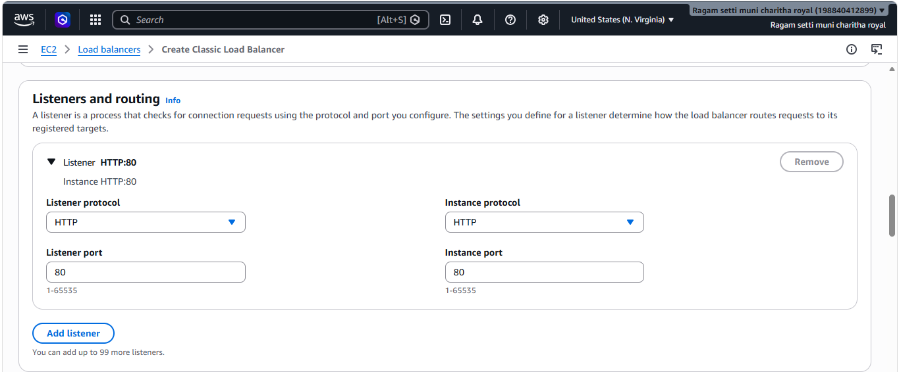
- Configured health check with HTTP protocol, port 80, and ping path /index.html.
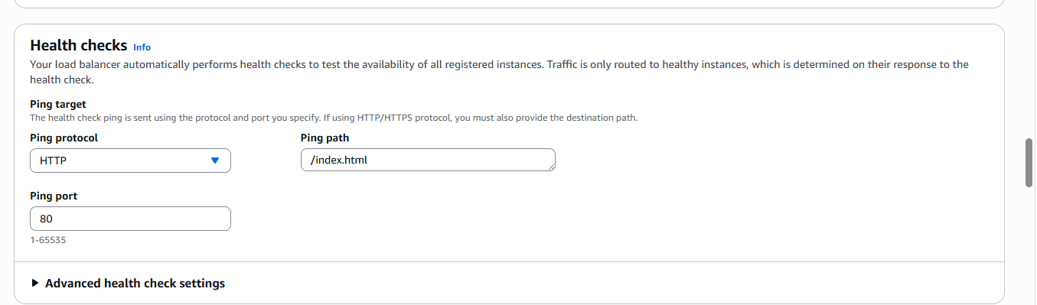
- Selected and registered the running EC2 instance with the Classic Load Balancer.
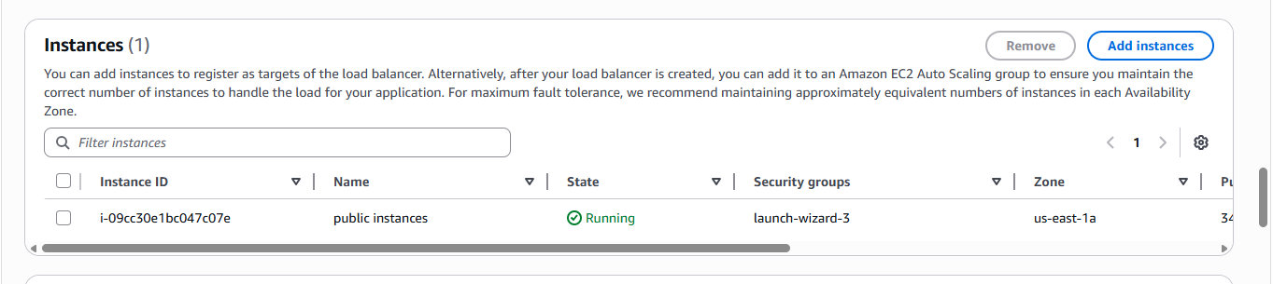
- Classic Load Balancer classic-LB was created successfully and is showing 1 instance in service.
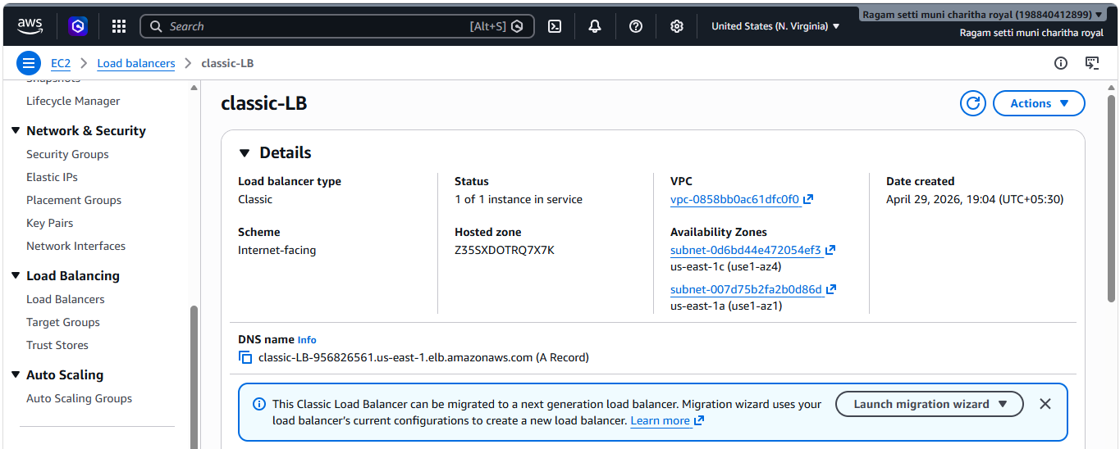
- verified the Classic Load Balancer DNS endpoint successfully displaying the web page
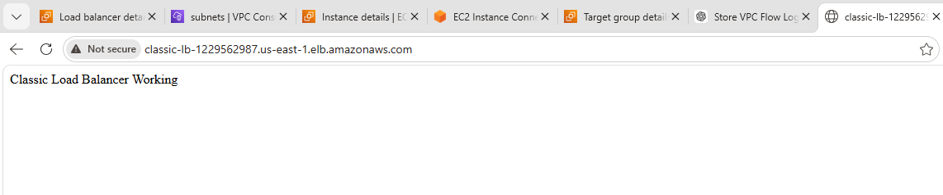
2.Configure Application Load balancer.
Clicked Create Load Balancer and selected Application Load Balancer.
- Entered load balancer name and selected Internet-facing scheme.
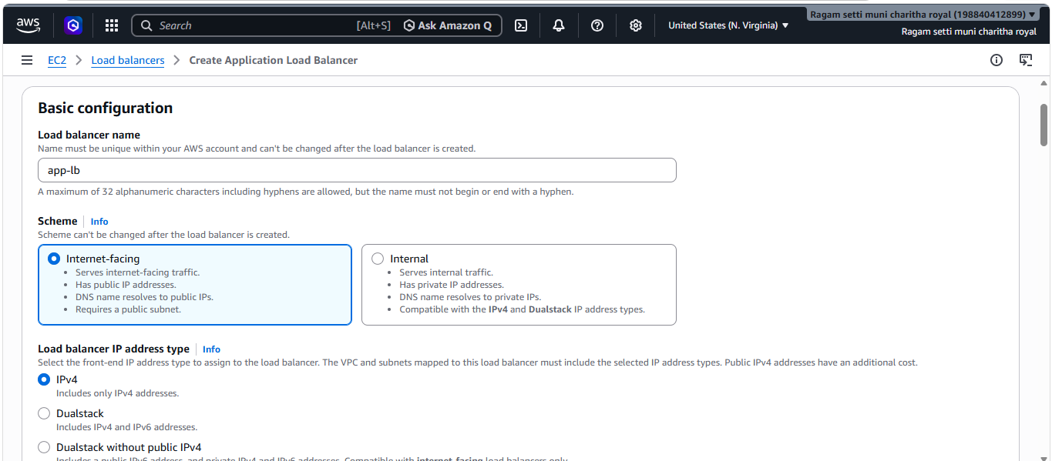
- Selected VPC and multiple public subnets.
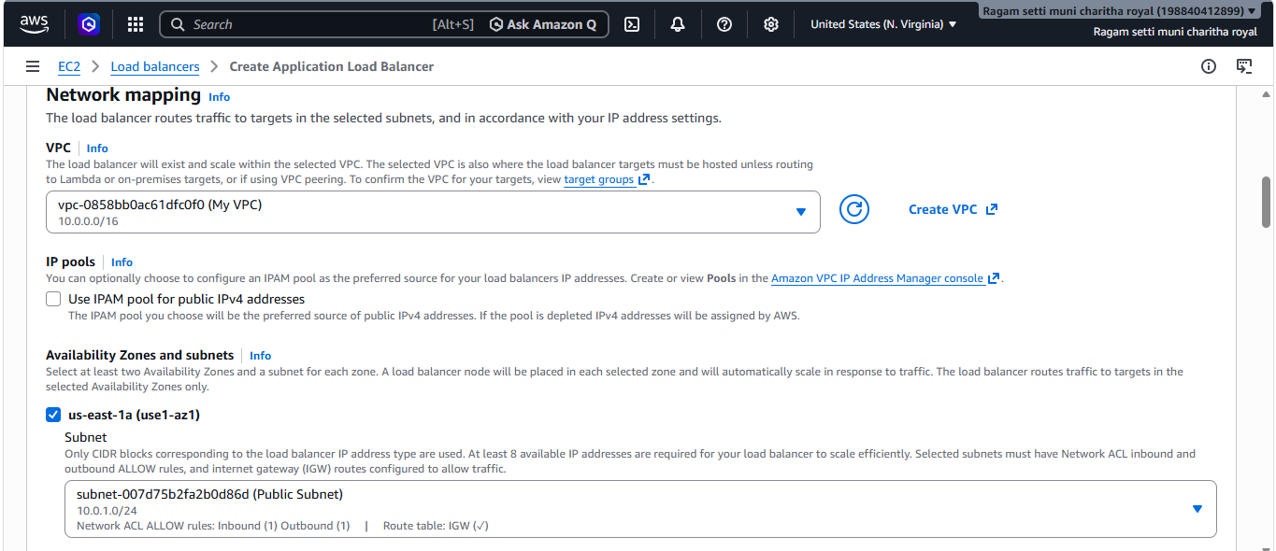
- Attached security group allowing HTTP (80) traffic.
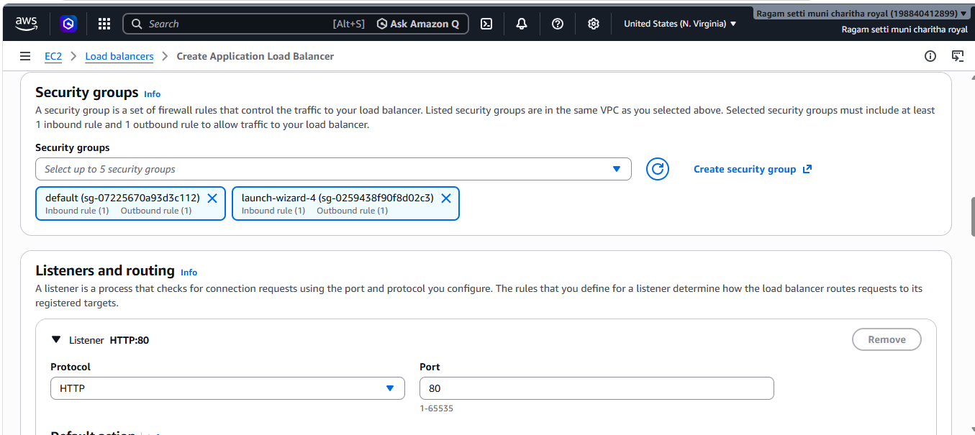
- Configured listener as HTTP : 80.
- Created target group and registered EC2 instance.
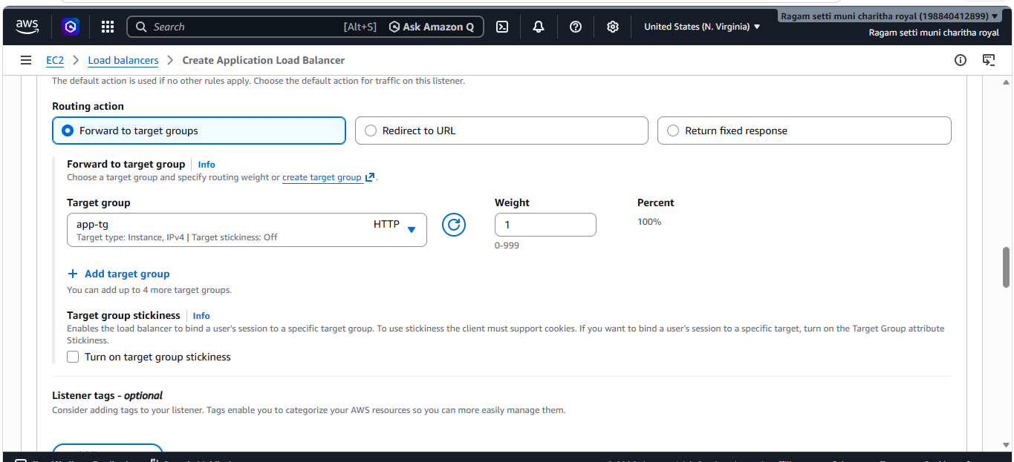
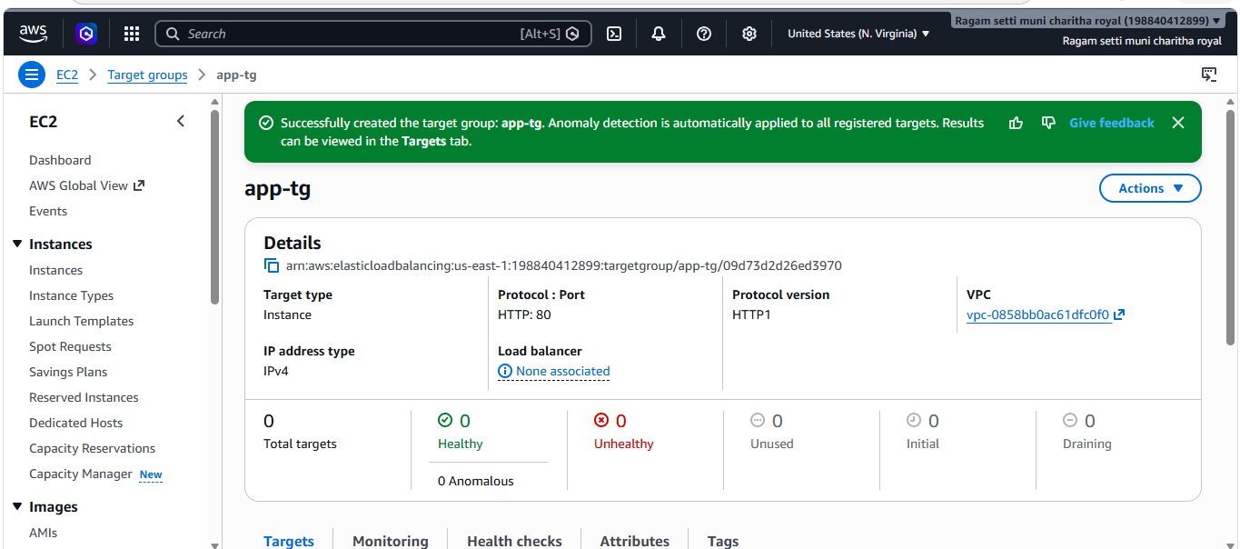
- Reviewed settings and created the Application Load Balancer successfully.
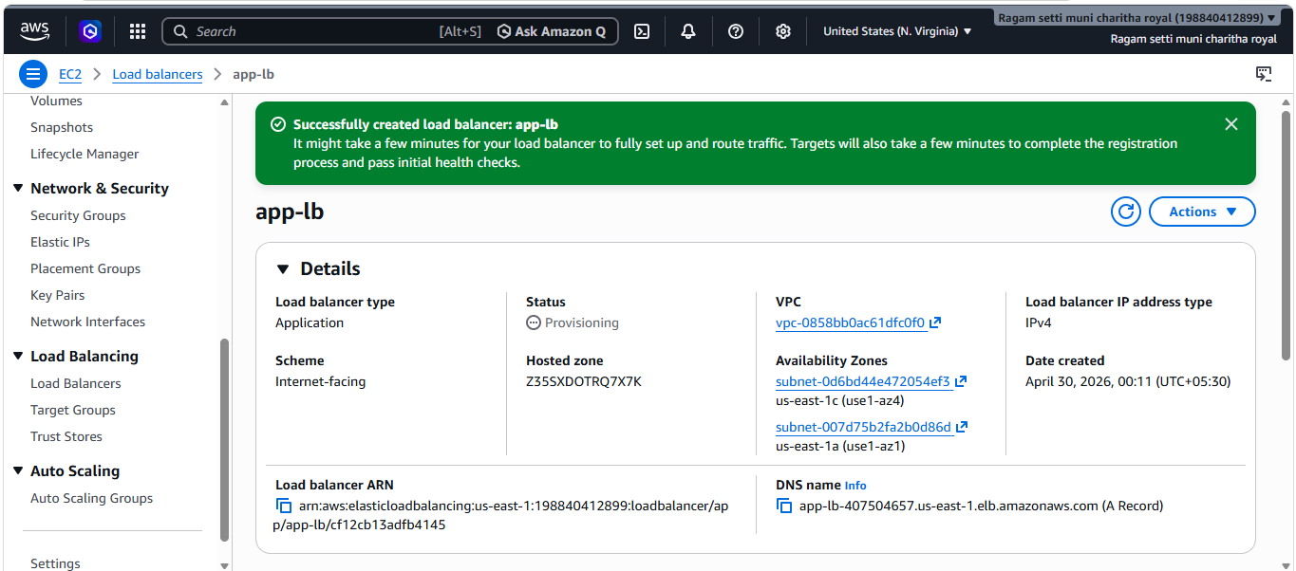
- Verified the DNS endpoint in browser.
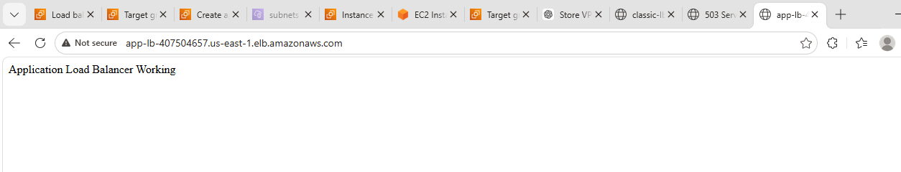

3.Configure Network Load balancer.
- Clicked Create Load Balancer and selected Network Load Balancer.
- Entered load balancer name and selected Internet-facing scheme.
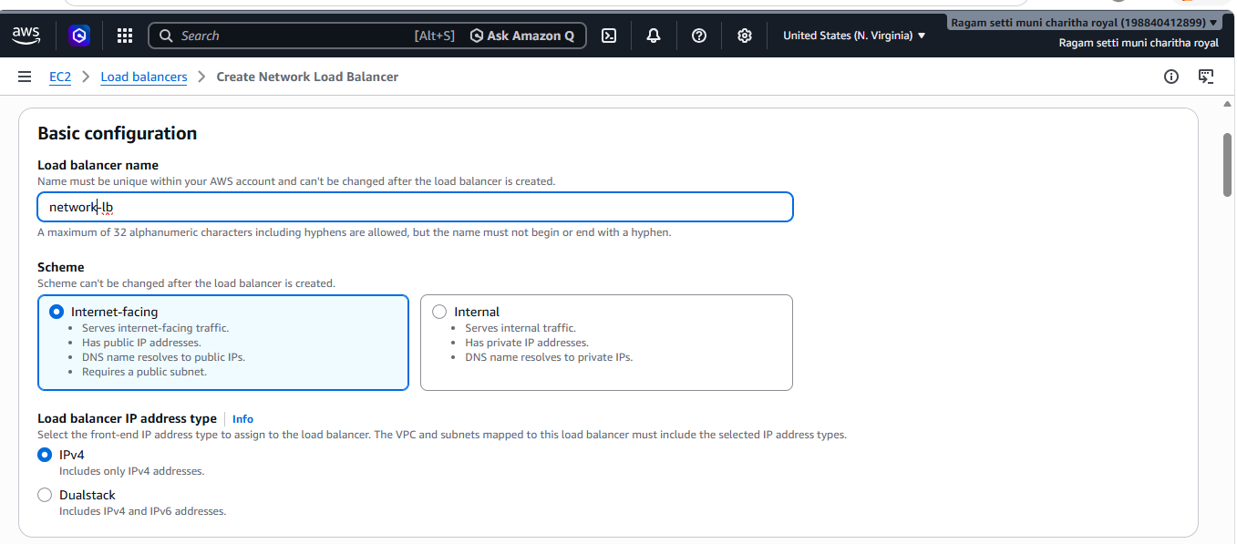
- Selected VPC and multiple public subnets.
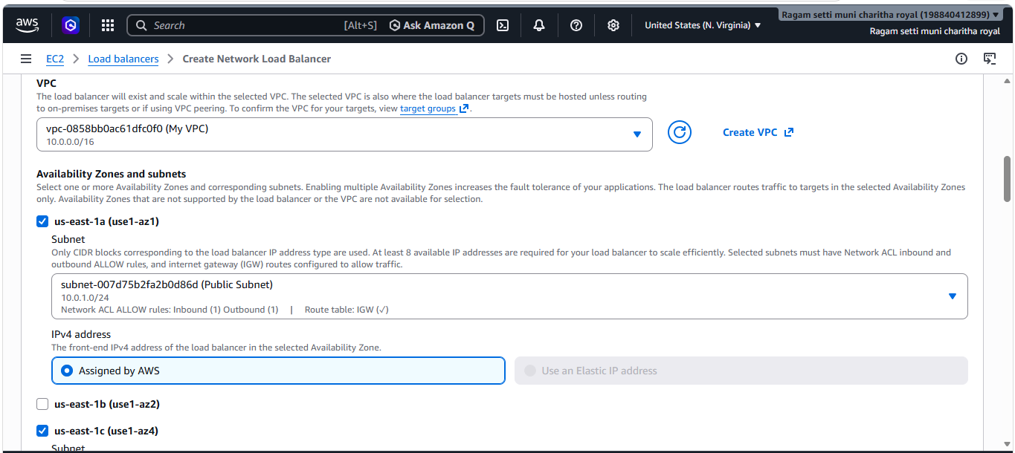
- Configured listener as TCP : 80.
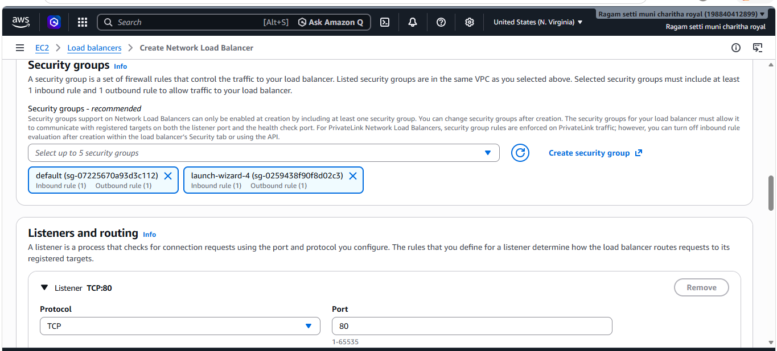
- Created target group with protocol TCP and registered EC2 instance.
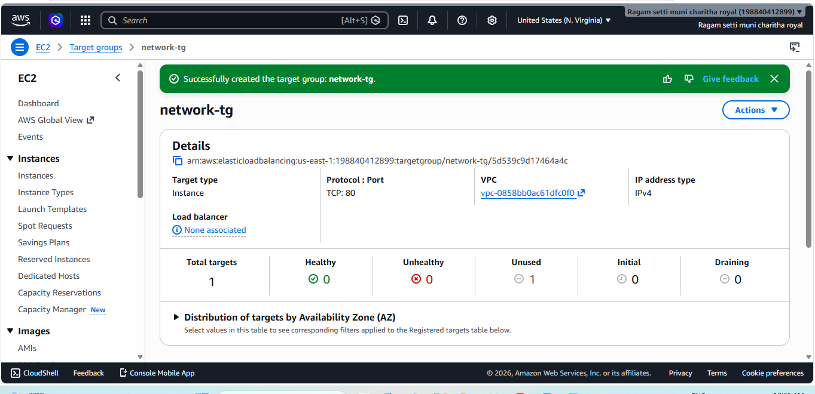
- Attached the target group to the Network Load Balancer.
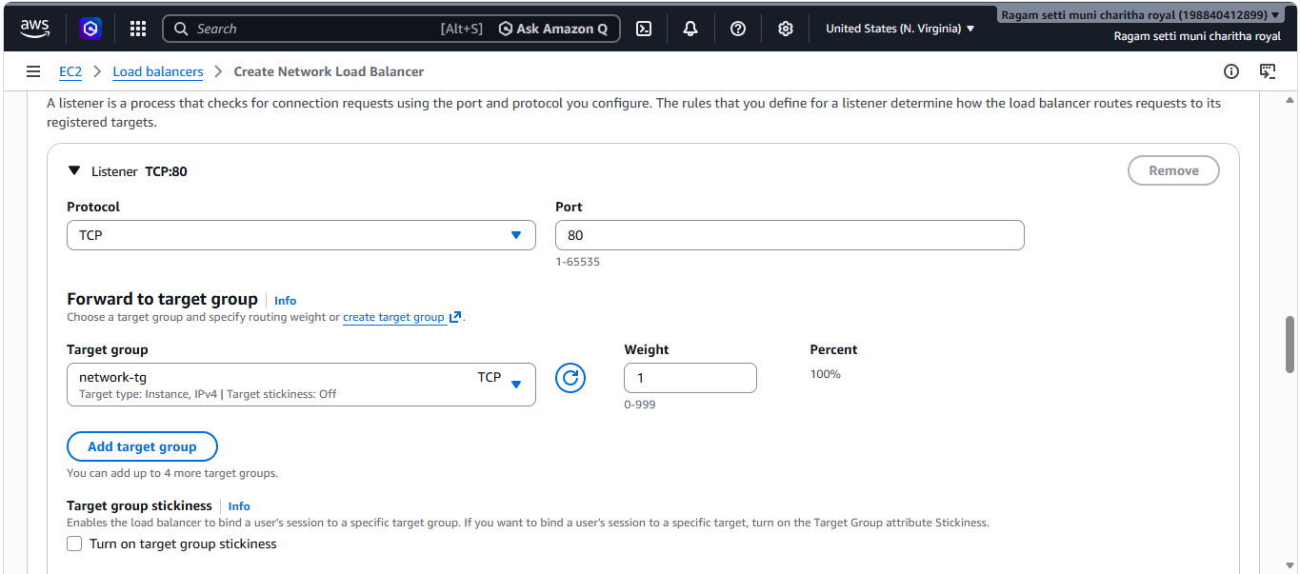
- Reviewed settings and created the Network Load Balancer successfully.
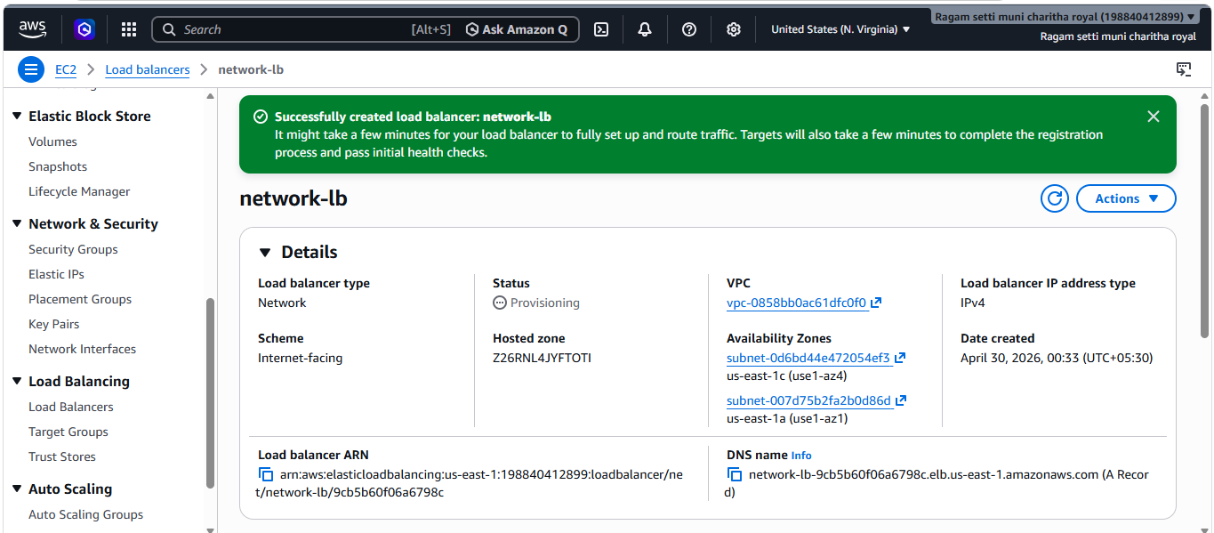
- Verified the DNS endpoint connectivity.
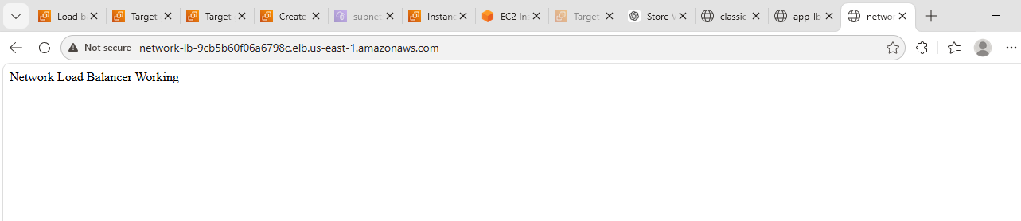
4.Attach SSL for application load balancer.
5.Map Application load balancer to R53.
- Requested a public SSL/TLS certificate using AWS Certificate Manager (ACM) for secure domain communication.
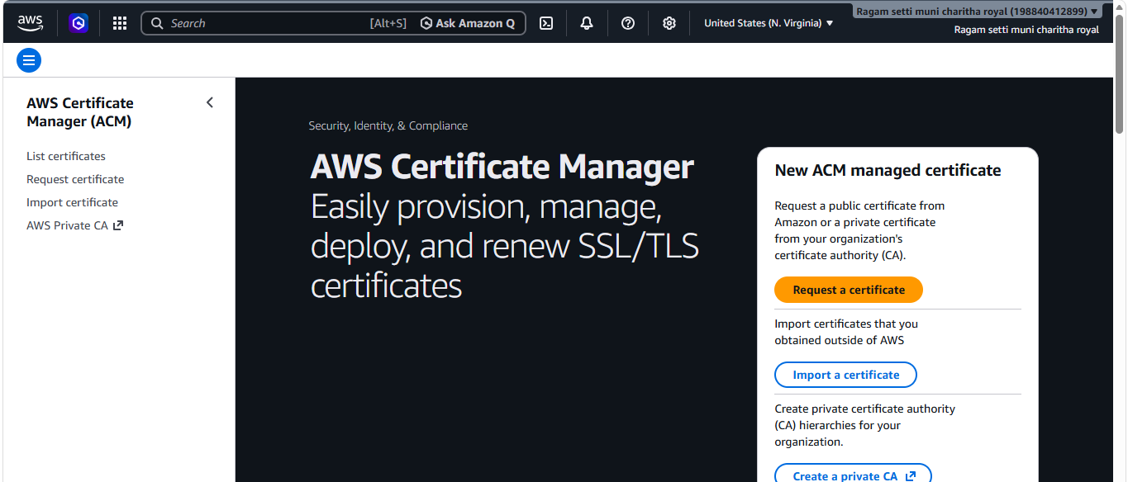
- Requested an SSL certificate for the domain (*.sudoslove.xyz) using DNS validation in ACM and successfully validated it to obtain an issued certificate.
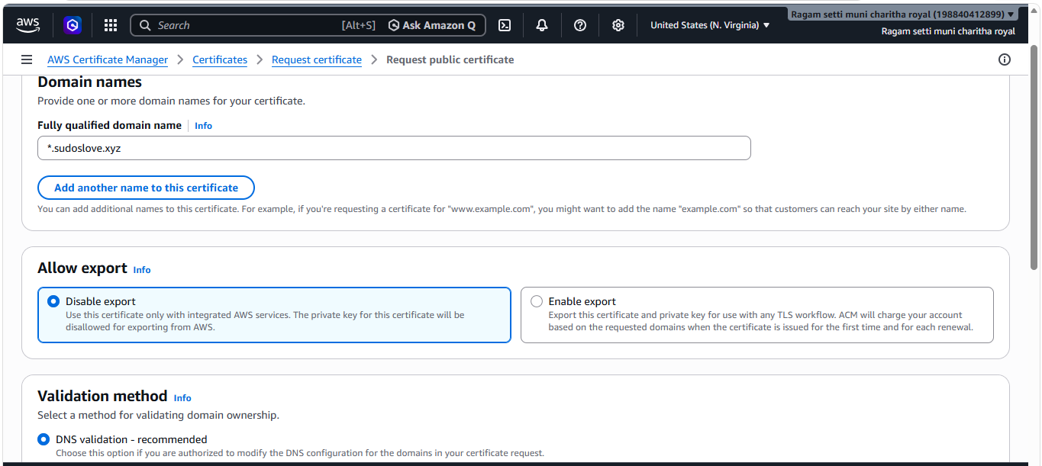
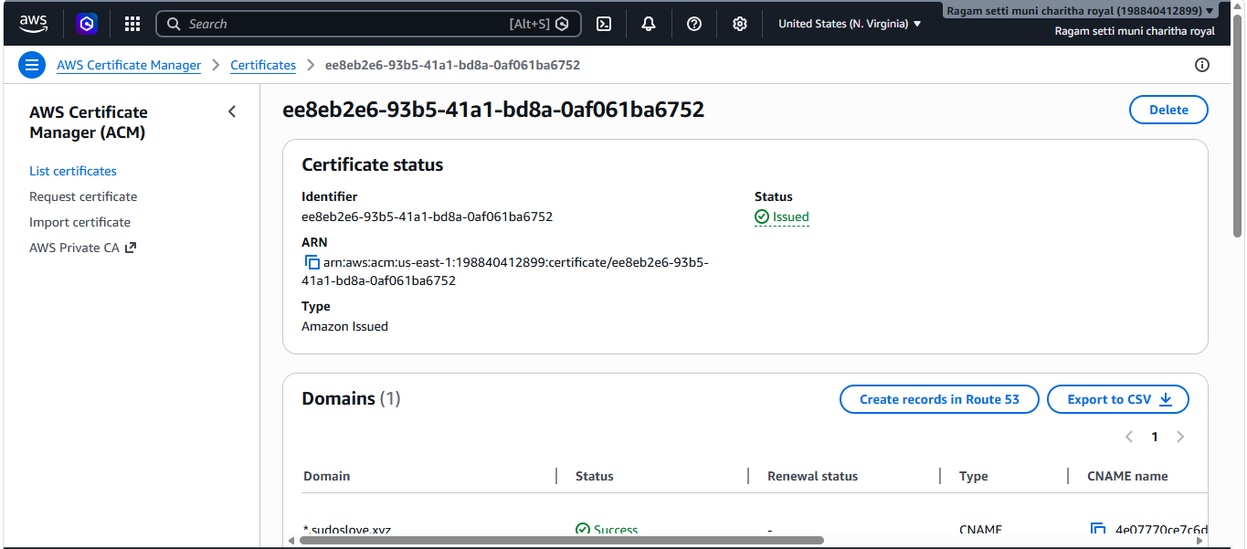
- Configured an HTTPS (port 443) listener on the Application Load Balancer and forwarded incoming traffic to the target group.
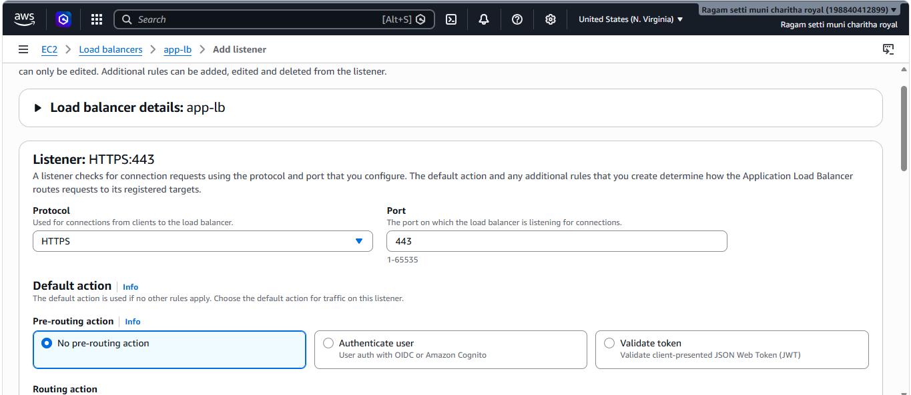
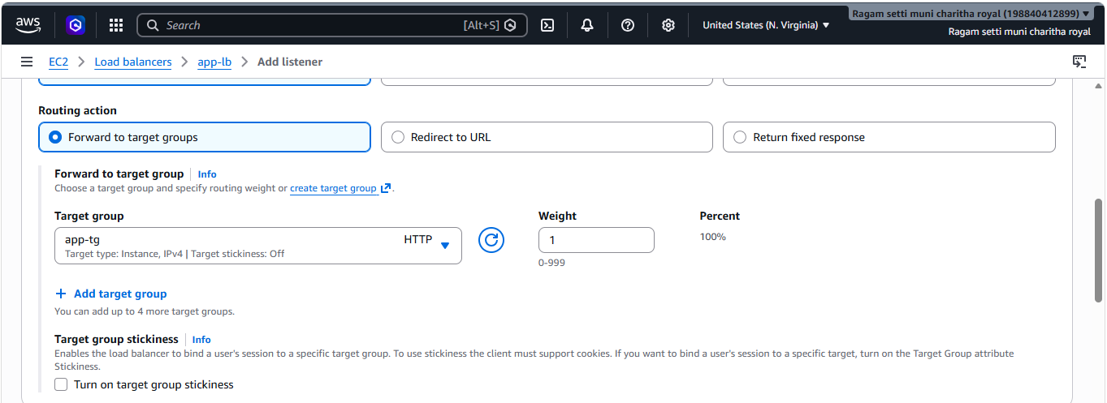
- Attached the ACM-issued SSL/TLS certificate to the HTTPS (443) listener on the Application Load Balancer to enable secure traffic handling.
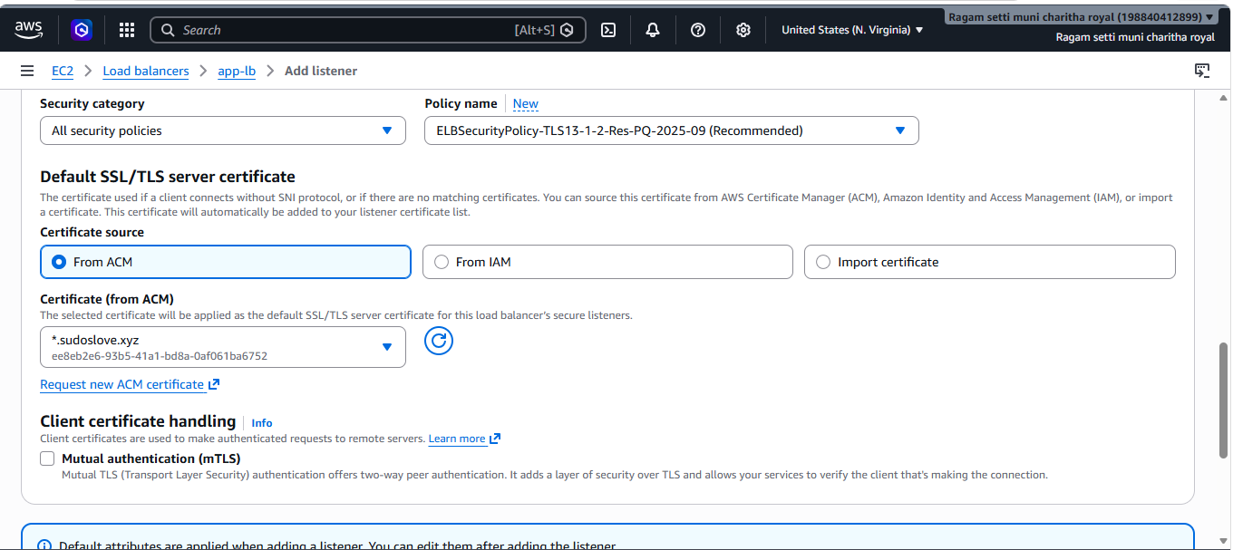
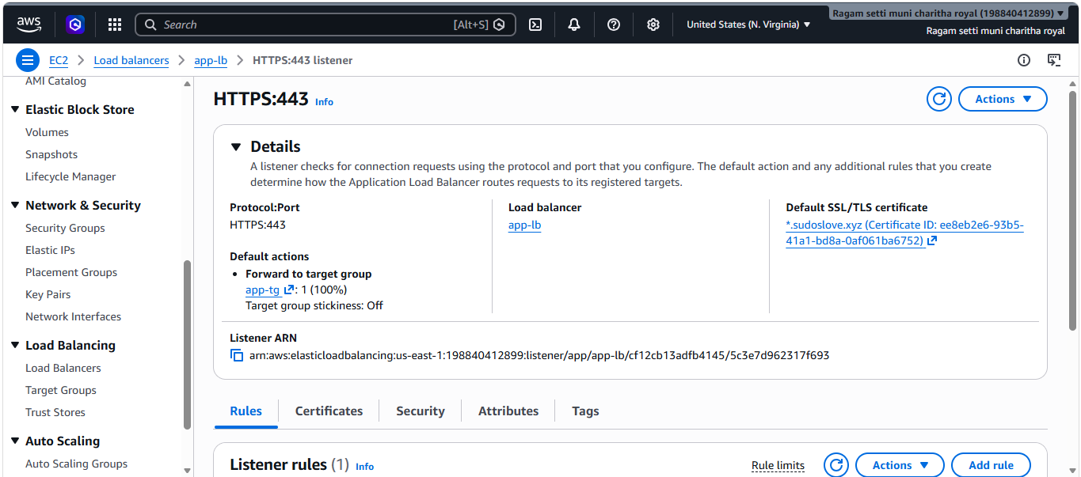
- Created a Route 53 alias record pointing the domain to the Application Load Balancer and configured HTTP (port 80) to HTTPS (port 443) redirection for secure access.
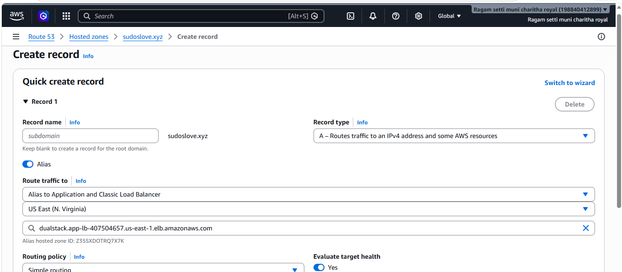
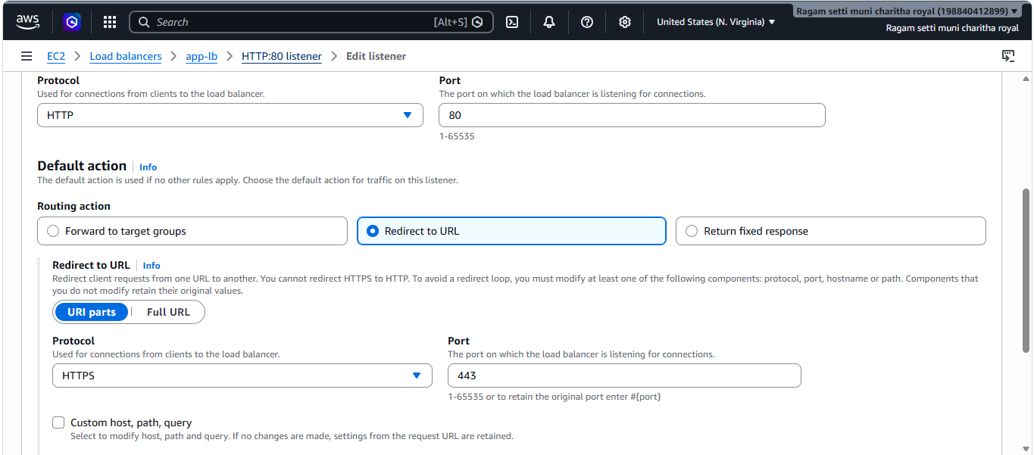
- Successfully verified secure access by loading the application via HTTPS using the custom domain through the Application Load Balancer.
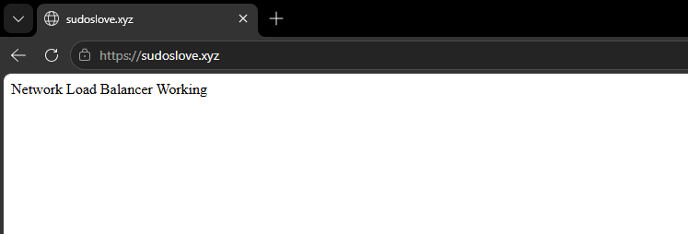
6.Push the application load balancer logs to S3.
- Created an S3 bucket (alb-logs-bucket-01) in the same region to store Application Load Balancer access logs.
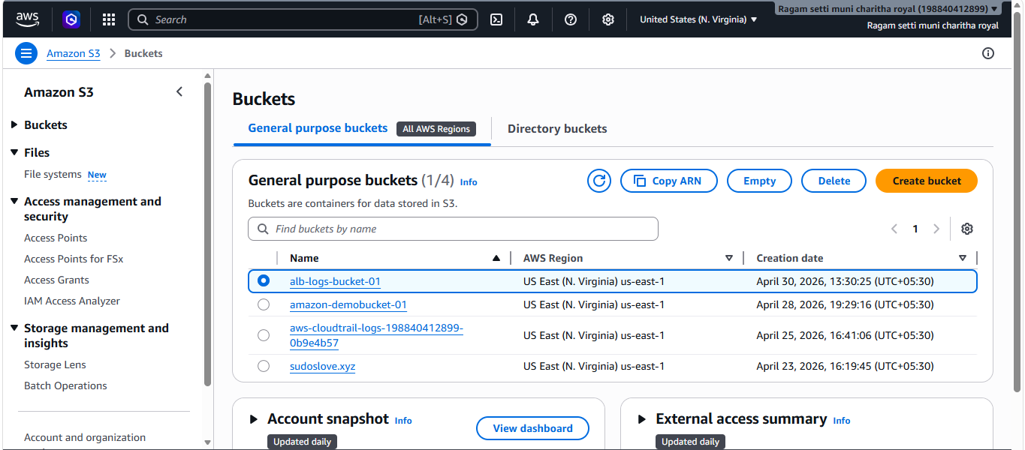
- Configured S3 bucket policy to grant Application Load Balancer permission to write access logs into the bucket.
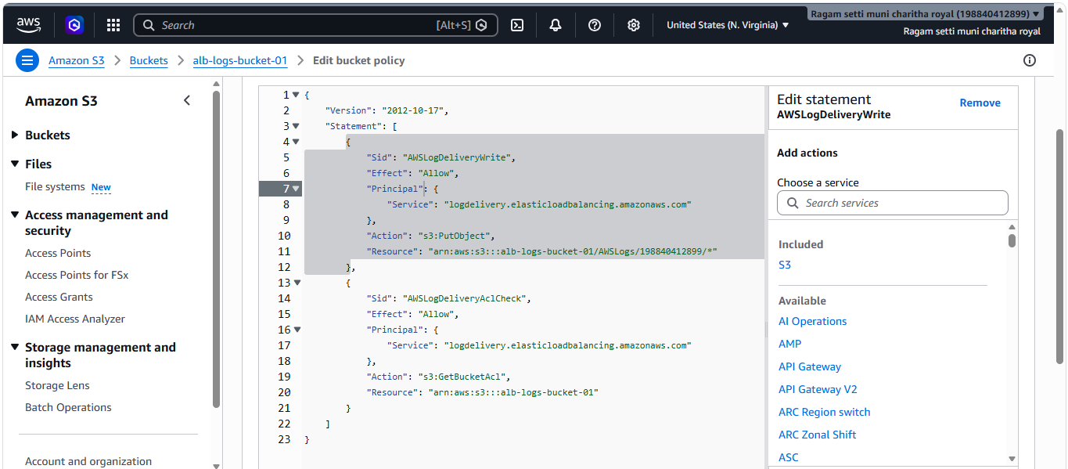
- Enabled access logging on the Application Load Balancer and configured it to store logs in the specified S3 bucket.
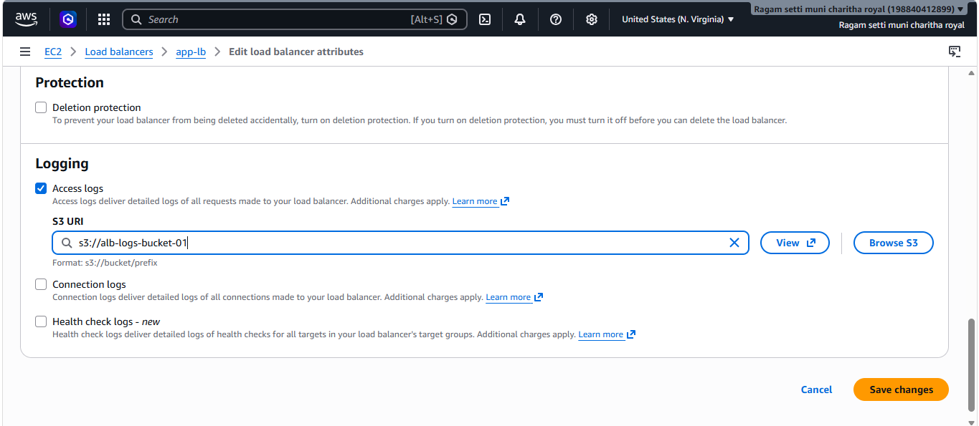
- Verified that Application Load Balancer access logging is successfully enabled and linked to the configured S3 bucket.
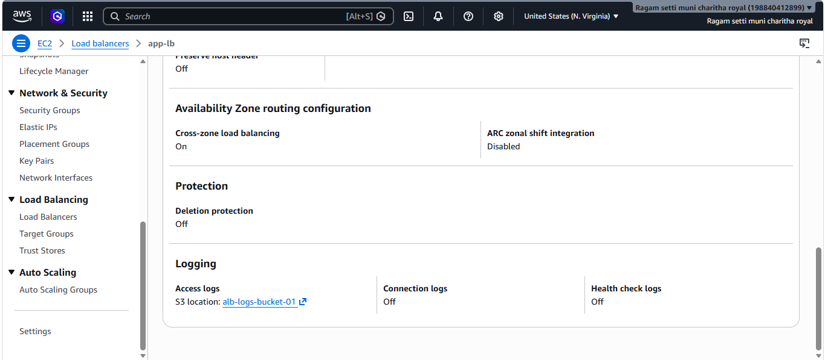
- Verified that Application Load Balancer access logs are successfully generated and stored in the S3 bucket under the AWSLogs directory.

